Population UV Irradiance in the US from 2004-2015

DATA 824

Abigail Kaff

7/26/2019

**Abstract**

This analysis gave insight into changes in UV Irradiance from 2004-2015 in the US. It showed that year to year there has been different amounts of UV irradiance given off. It also showed that location plays a large role in the amount of UV Irradiance is given year to year. The southern states, specifically Texas gets some of the highest rates of UV Irradiance year to year. The most interesting finding for myself is that there are no specific findings that UV Irradiance is increasing drastically year to year to say that this is a problem facing the world. This is something that is important to be monitored but does not pose a massive risk to humans as the years move forward.

**Summary**

UV irradiance is something that affects all humans everyday whether they are aware of it or not. It can pose a large threat with large amount of expose and not being properly protected. Also, it can’t be seen, which in and of itself can be terrifying, the wavelengths of uv radiation are unseen by the human eye but are known to affect them.[1] This analysis was intended to provide some understanding on how much UV irradiance changes over time throughout the United States. This analysis takes into account the population as well which is important because there are places that can receive uv radiation, but its not having a lot of human exposure so it doesn’t pose a large threat like another area that has a huge population.

**Background**

What does UV irradiance do to humans? UV irradiance is an unseen wavelength of light that has three different wavelengths, short, medium and long. The one that is most focused on and is important is long, this is because long can have real affects on humans. Long wavelengths penetrate the skin and can cause aging and skin cancer which is a primary reason why looking at UV irradiance is so important. It may be surprising, but UV irradiance wasn’t measured rigorously until 2004 and that can be seen in the data. The National Institute of Standards and Technology created the scale in which UV irradiance is measured on, so this is a new initiative that has impacted how UV irradiance interacts with the Earth.[2]

**Figures**

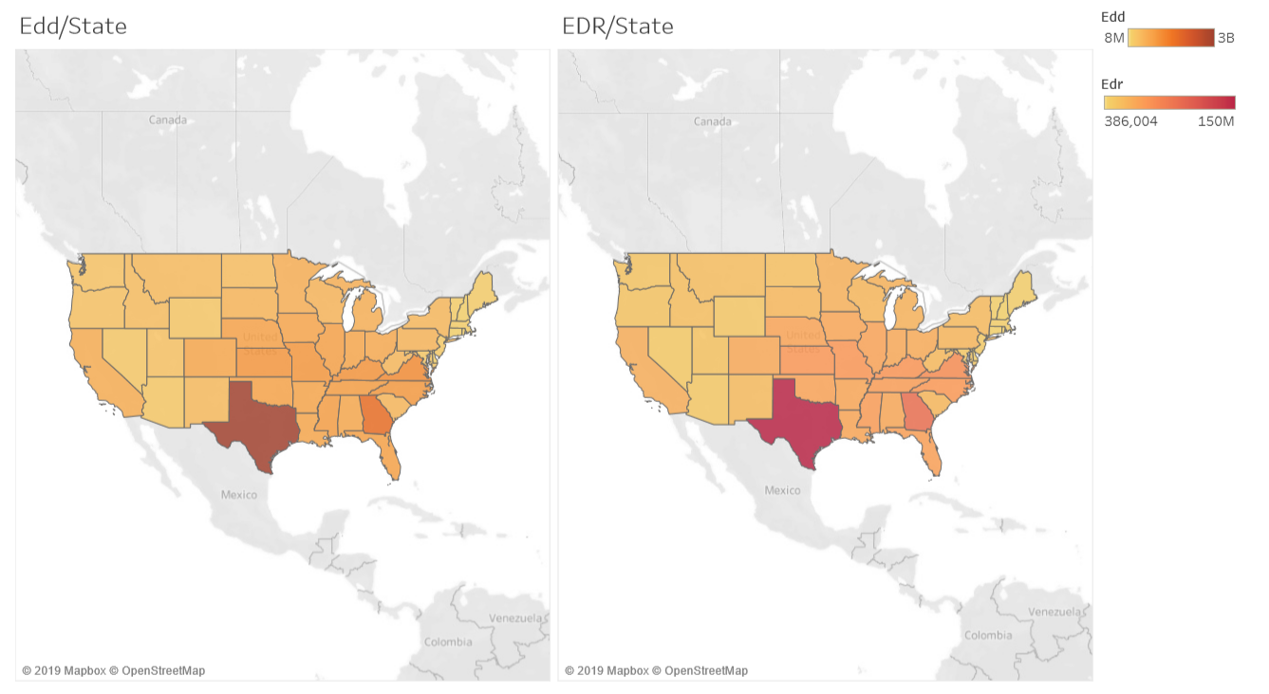

Image 1.

EDD and EDR are measurements of UV irradiance calculated by the unit of J/m2. EDD is the overall daily amount while EDR is the amount at solar noon. Looking that them in comparison is interesting, though there is not that large of a difference between heavily affected states, however it gives clarity on the impact that solar noon has on each individual place.

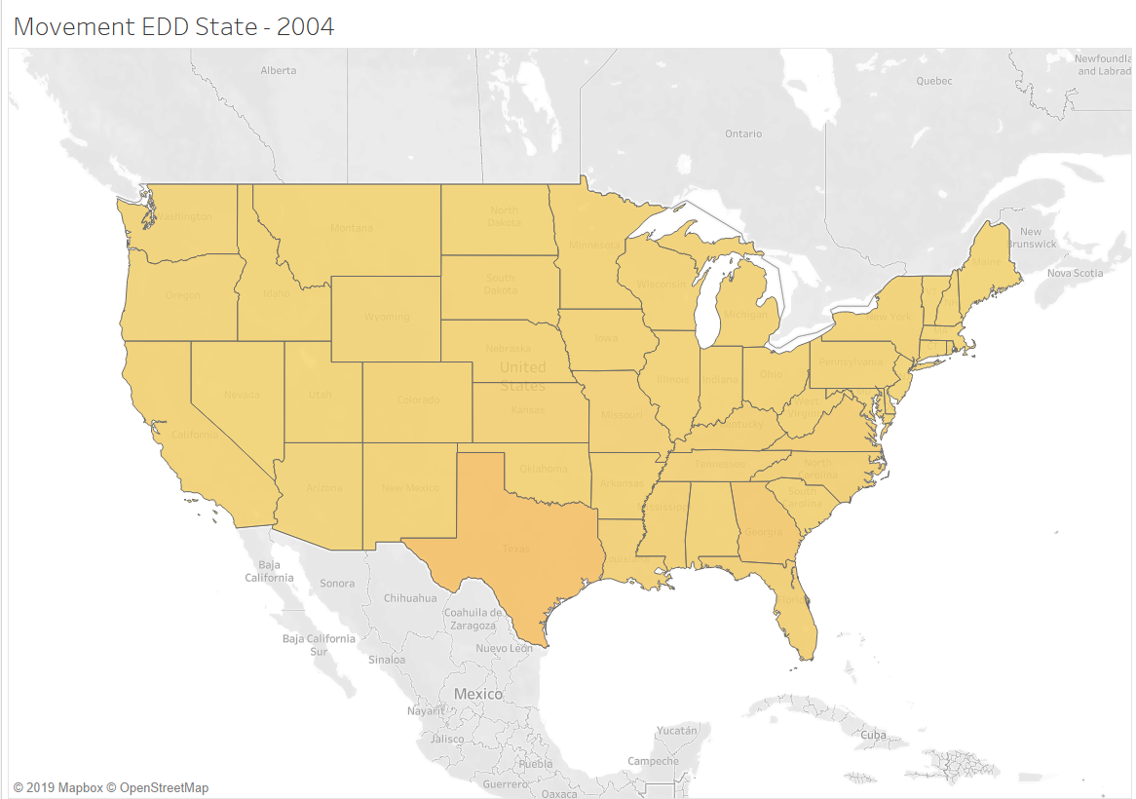

Image 2.

Image 2 is important to note in the data because it looks at all UV irradiance in 2004 and that was the year the unit of measurement was calculated which makes looking at this year a little unhelpful. The data began to be accumulated in October of that year so it really is not in the same playing field as all the other years, but was still included in the analysis for purposes of keeping all the records.

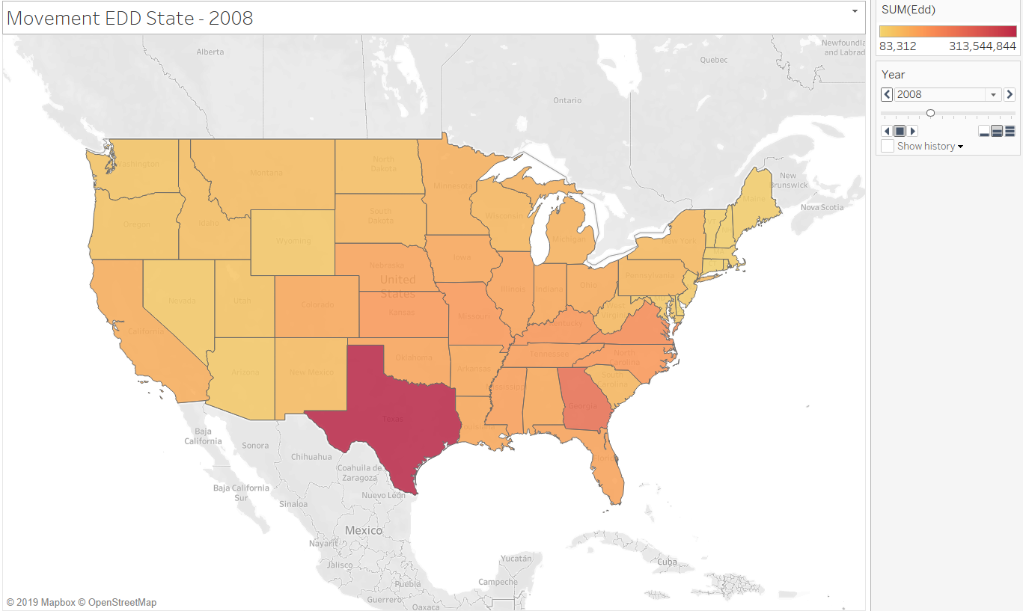

Image 3.

It seemed important to look at another of the same image like in image 2 because it shows a drastic change in the amount of uv irradiance that was accumulated throughout that year. The amount of shading on each state shows the amount of uv irradiance that happened throughout the year. This amount per state reigns true throughout the other years, and because population size does play a large role in this Texas always seems to be the most prevalent.

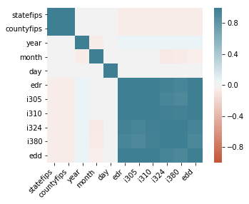

Image 4.

Including a correlation plot as a final graph in the analysis just because that wasn’t a lot of correlation going on throughout the analysis. This does give a little information on how all the variables work together in the data set though.

1. <https://www.ccohs.ca/oshanswers/phys_agents/ultravioletradiation.html>
2. <https://www.nist.gov/programs-projects/long-term-monitoring-ultraviolet-irradiance-scale>